public void deletePos(int n) {  
 if(head == null) {  
 return;  
 }  
 else {  
 Node current = head;  
  
 int pos =n;  
 for(int i = 1; i < pos; i++){  
 current = current.next;  
 }  
  
 if(current == head) {  
 head = current.next;  
 }  
 else if(current == tail) {  
 tail = tail.prev;  
 }  
 else {  
 current.prev.next = current.next;  
 current.next.prev = current.prev;  
 }  
 current = null;  
 }  
}

The deletePos() method was used to delete the song. The songs position would be inputed

The song Wanye shown at the top, which is first in the list and at position 1, will be the song to be deleted by the user.

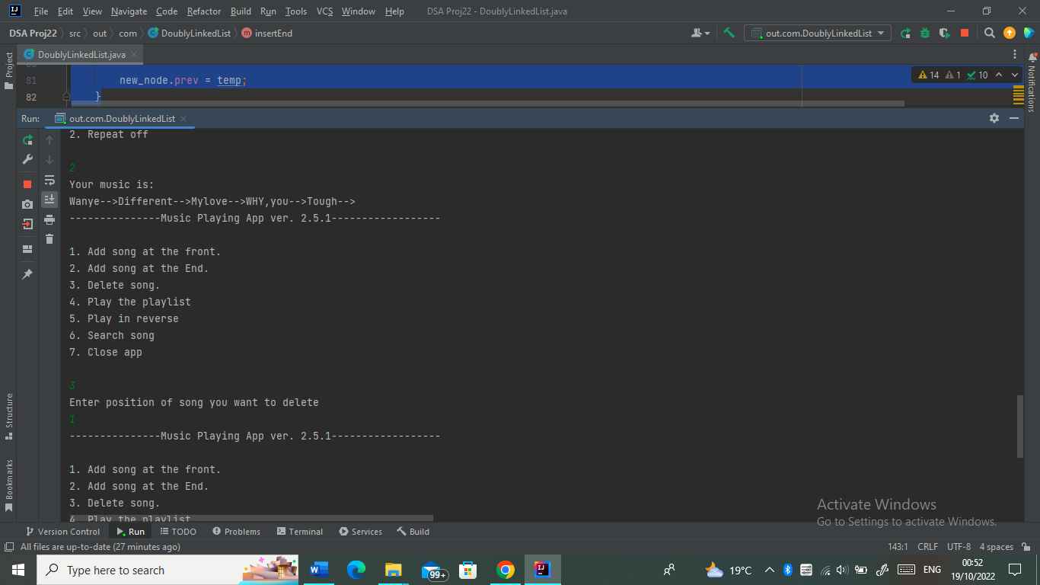

The song Wanye is shown missing from the playlist after it was deleted